Exercise: DOM Manipulations
Problems for exercises and homework for the "JavaScript Advanced" course @ SoftUni". Submit your solutions in the SoftUni judge system at https://judge.softuni.bg/Contests/1550/Exercise-DOM-Manipulations.

Sections
You will receive an array of strings. For each string, create a div with a paragraph with the string in it. Each paragraph is initially hidden (display:none). Add a click event listener to each div that displays the hidden paragraph. Finally, you should append all divs to the element with an id "content".

Example
 → 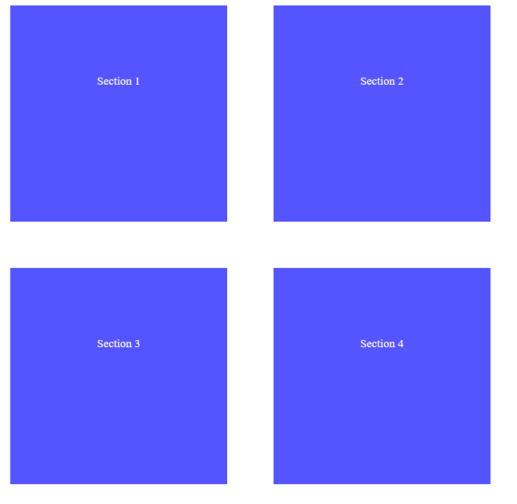

Notification
Write a function that receives a string message and displays it inside a div with an id "notification" for 2 seconds. The div is initially hidden and when the function is called, it must be shown. After 2 seconds, hide the div. In the example below, a notification is shown when you click the button.

Example
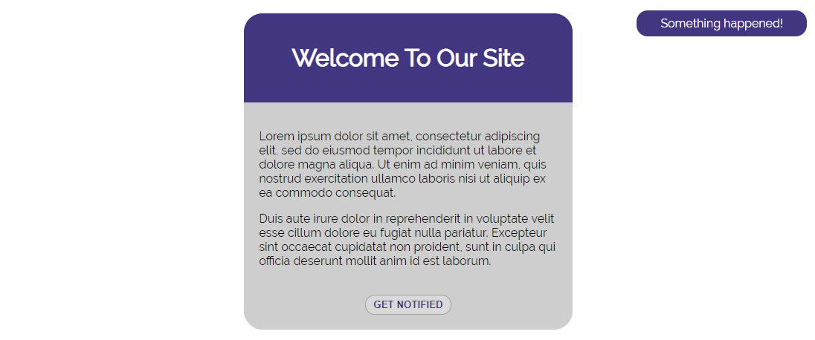
When we click the [GET NOTIFIED] button, a div appears in our upper-right corner. It should disappear in 2 seconds.

Time Converter
Create a program that converts different time units. Your task is to add a click event listener to all [CONVERT] buttons. When a button is clicked, read the corresponding input field, convert the value to the three other time units and display it in the input fields.

Example
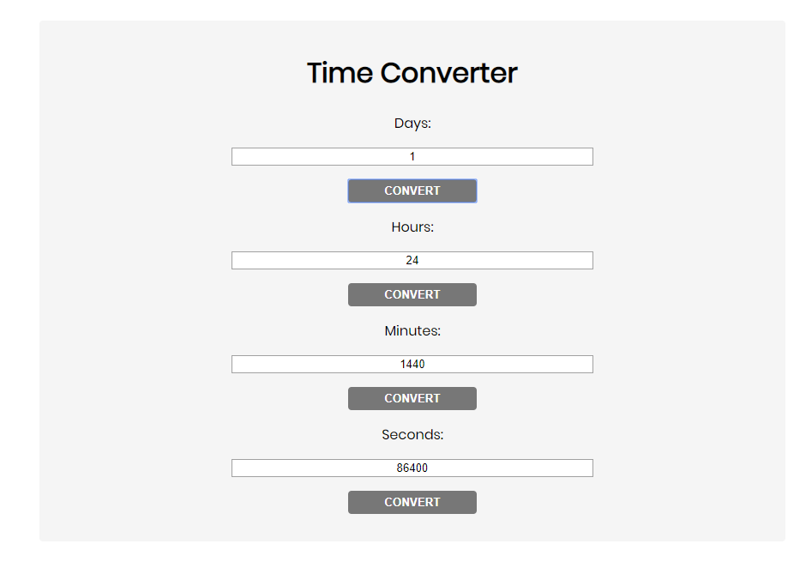
One day is equal to 24 hours/1440 minutes/86400 seconds. Whichever button we click, the input fields should change depending on the added value on the left. (For example, if we write 48 hours and click convert the days, the field value should change to 2).

Locked Profile
In this problem, you should create a JS functonality which shows and hides the additional
information about users.
- 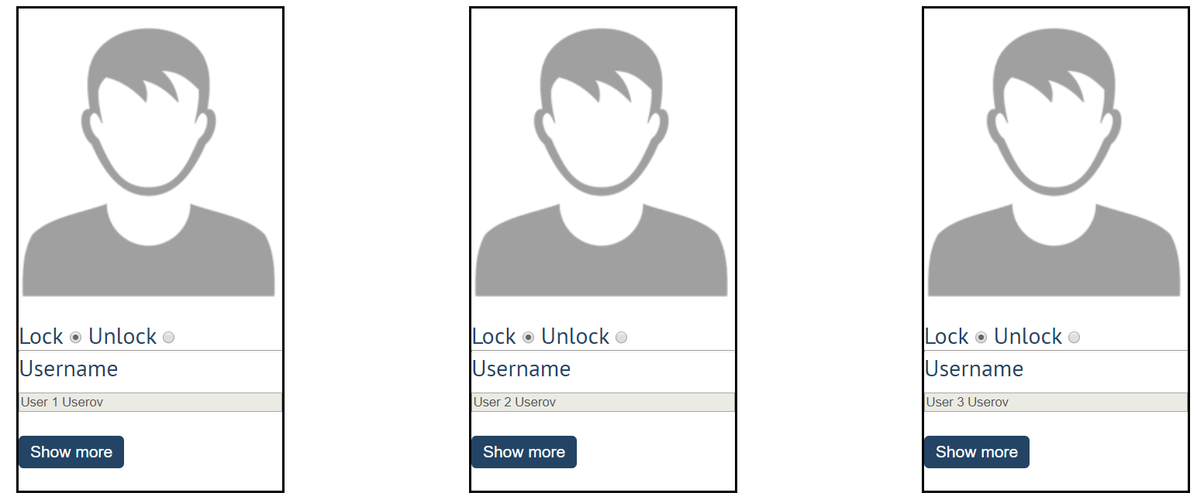
When one of the [Show more] buttons is clicked, the hiden information inside the div should
be shown, only if the profile is not locked! If the current profile is locked, nothing should
happen.
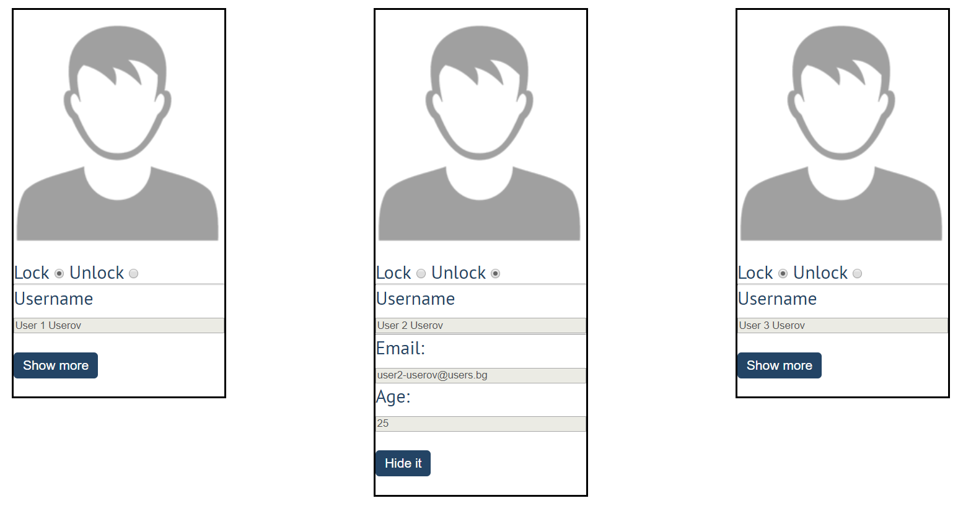
If the hidden information is displayed and we lock the profile again, the [Hide it] button
should not be working! Otherwise, when the profile is unlocked and we click on the [Hide it]
button, the new fields must hide again.

Encode and Decode Messages
In this problem, you should create a JS functonality which encodes and decodes some
messages which travel to the network.
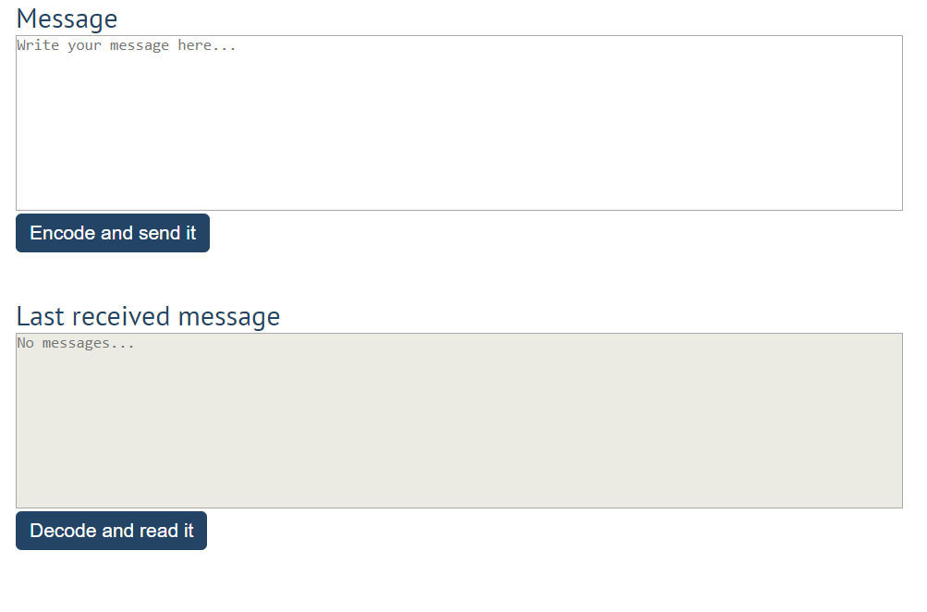
This program should contain two functionalities.
The first one is to encode the given message and send it to the receiver.
The second one is to decode the received message and read it (display it).
When the [Encode and send it] button is clicked, you should get the given message from the first textarea. When you get the current message, you should encode it as follows:
- Change the ASCII CODE on every single character in that message when you add 1 to the current ASCII NUMBER, that represent the current character in that message
- Clear the sender textarea and append the encoded message to the receiver textarea
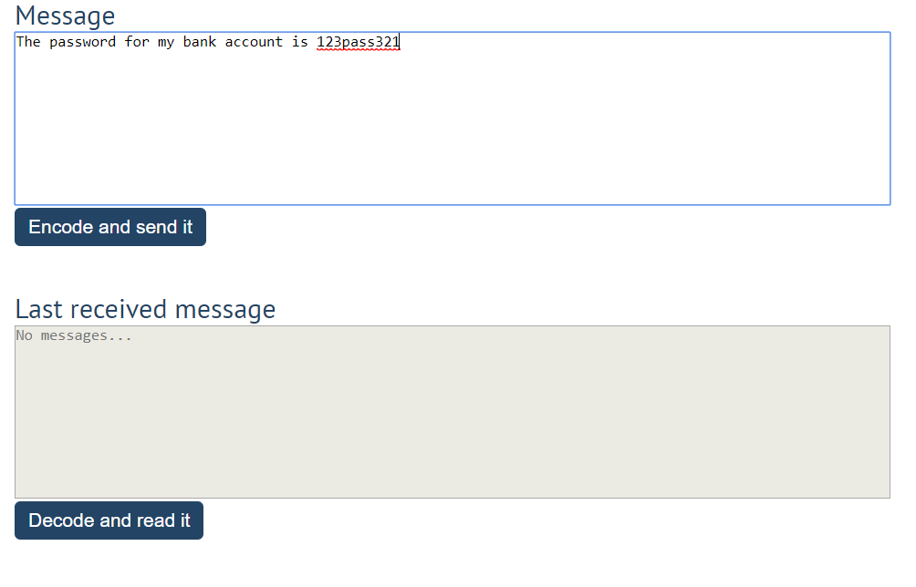
After clicking [Encode and send it] button the result should be:
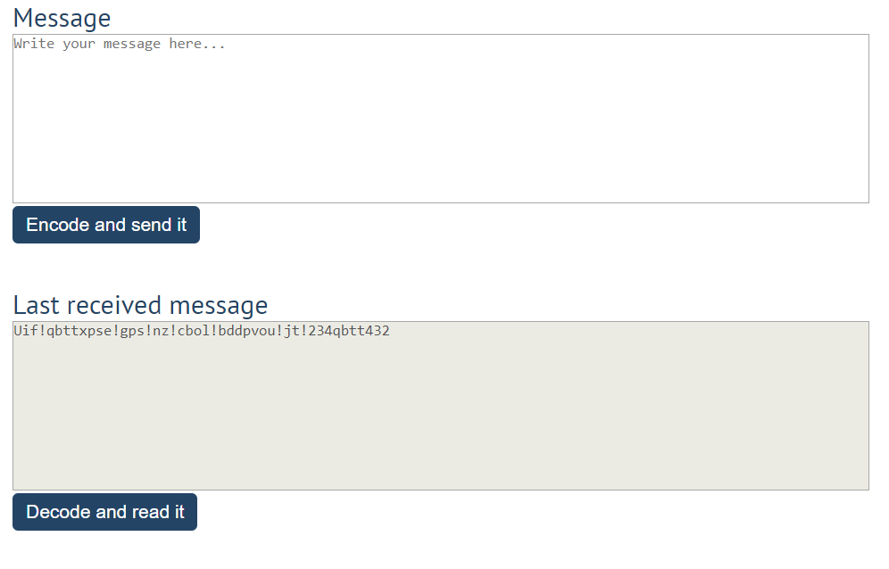
After that, when the [Decode and read it] button is clicked. You need to get the encoded message from the receiver textarea and do the opposite logic from encoding:
- Subtract 1 from the current ASCII NUMBER, that represents the current character in that message
- Replace the encoded message with the already decoded message in the receiver textrea, to make it readable
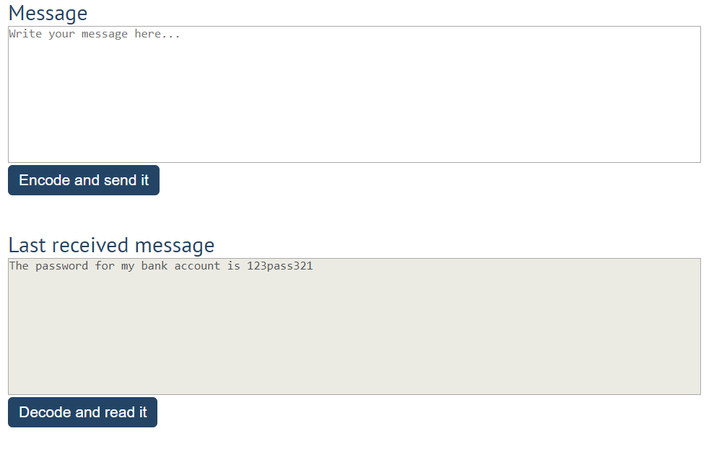

Table – Search Engine
Write a function that searches in a table by given input.
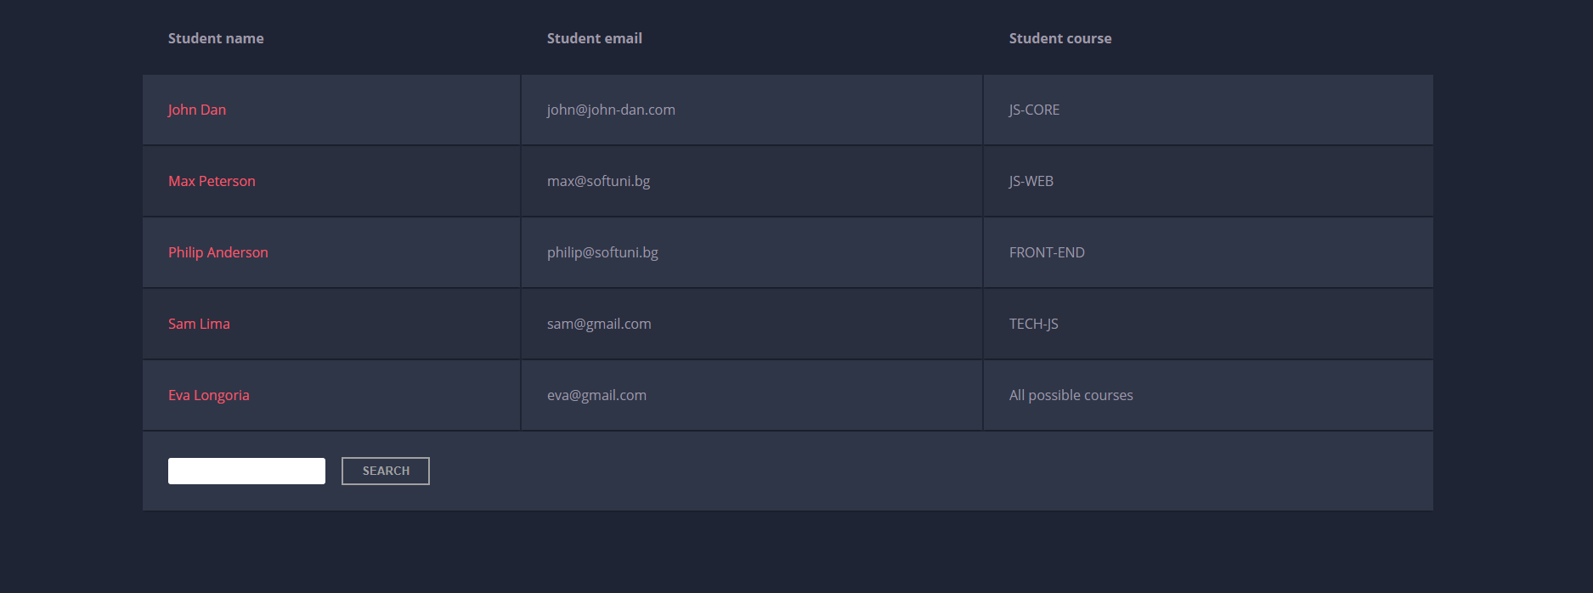
When the "Search" button is clicked, go through all cells in the table except for the first row (Student name, Student email and Student course) and check if the given input has a match (check for both full words and single letters).
If any of the rows contain the submitted string, add a select class to that row. Note that more than one row may contain the given string.
Оtherwise, if there is no match, nothing should happen.
Note: After every search ("Search" button is clicked), clear the input field and remove all already selected classes (if any) from the previous search, in order for the new search to contain only the new result.
For instance, if we try to find eva:
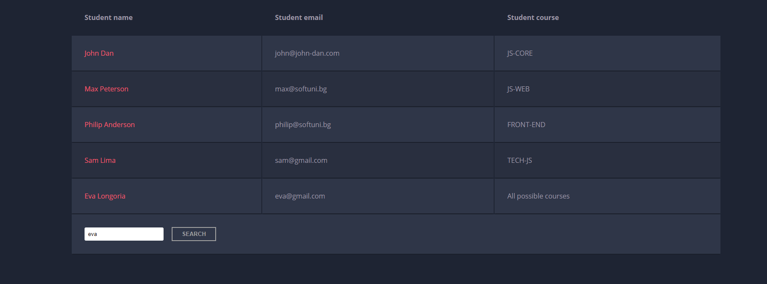
The result should be:
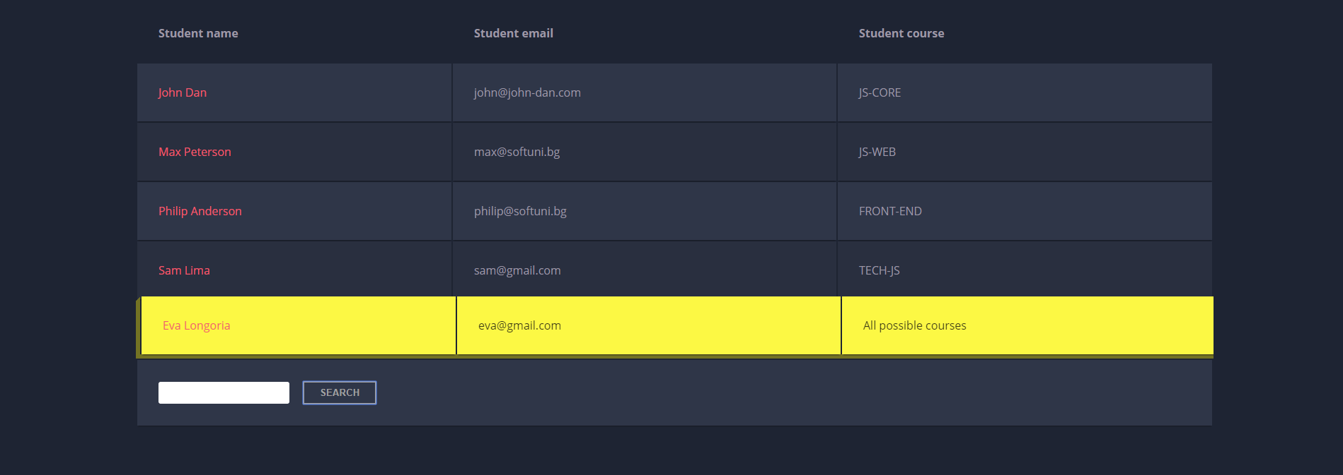
If we try to find all students who have email addresses in softuni domain, the expected result should be:
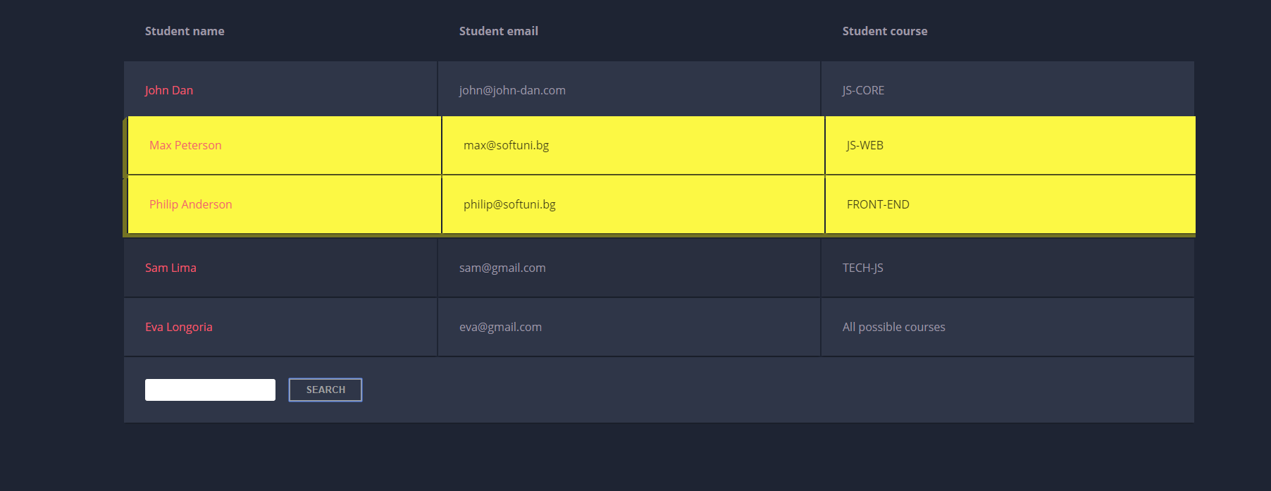

Furniture
You will be given some furniture as an array of objects. Each object will have a name, a price and a decoration factor.
When the "Generate" button is clicked, add a new row to the table for each piece of furniture with image, name, price and decoration factor (code example below).
When the "Buy" button is clicked, get all checkboxes that are marked and show in the result textbox the names of the piece of furniture that were checked, separated by a comma and single space (", ") in the following format: "Bought furniture: {furniture1} {furniture2}…".
On the next line, print the total price in format: "Total price: {totalPrice}" (formatted to the second decimal point). Finally, print the average decoration factor in the format: "Average decoration factor: {decFactor}"

Input Example
[{"name": "Sofa", "img": "https://res.cloudinary.com/maisonsdumonde/image/upload/q_auto,f_auto/w_200/img/grey-3-seater-sofa-bed-200-13-0-175521_9.jpg", "price": 150, "decFactor": 1.2}]

Examples
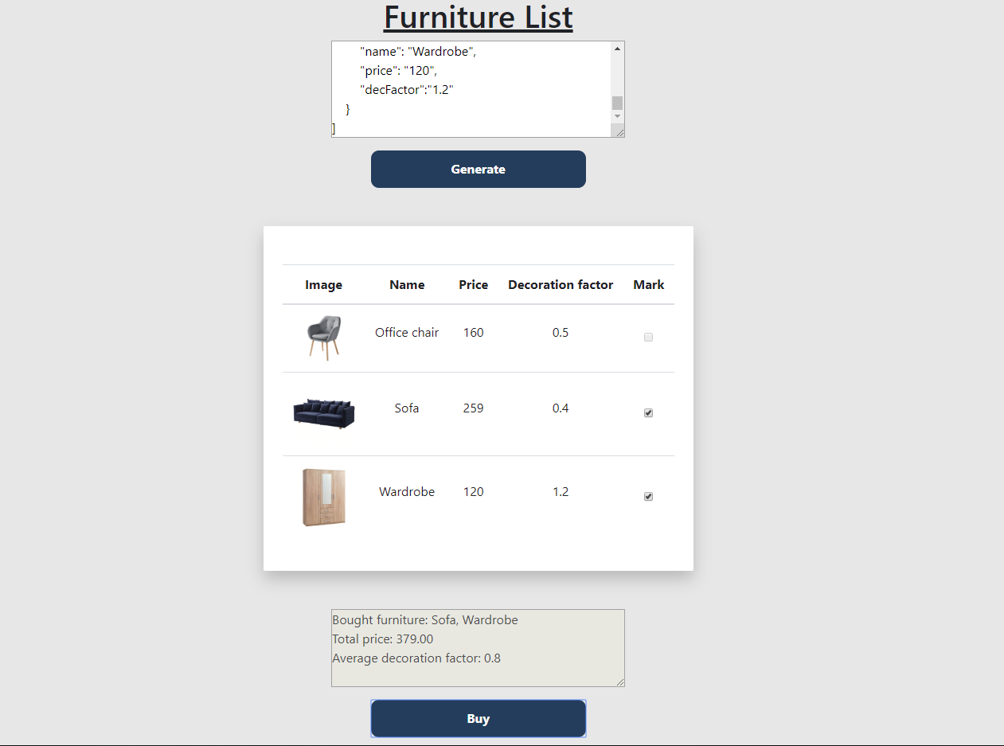
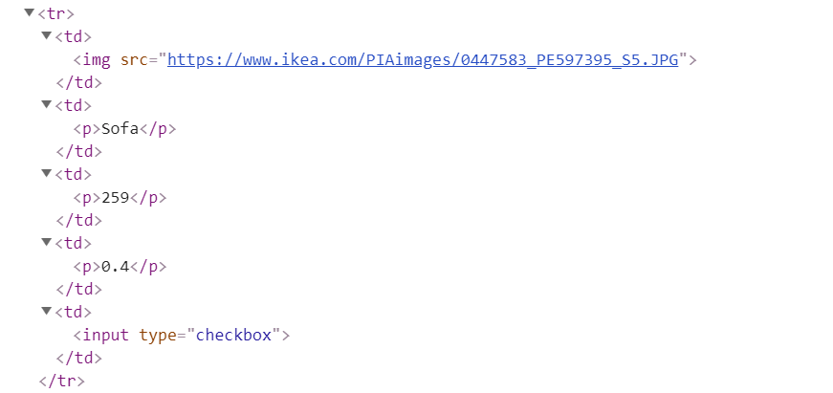

Cards
Write a function which checks cards, shows which one is greater and keeps history of all hands.
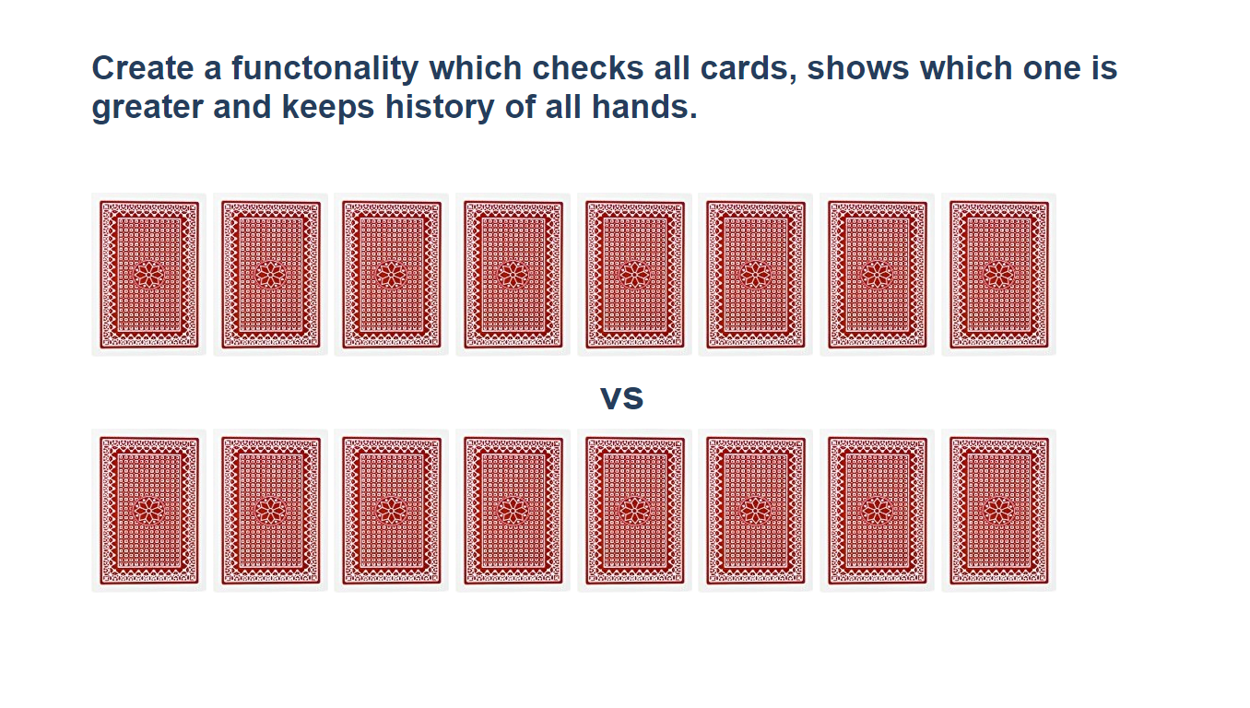
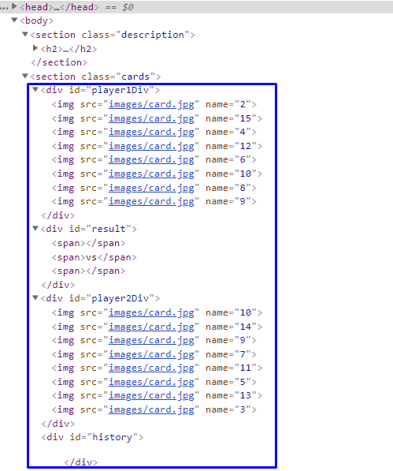
Firstly, add click events to all cards. When one of the cards is clicked, the current background card must be changed with the "whiteCard.jpg" picture (it is given in the skeleton) and the card name should be appended to one of the span elements in the div with id="result".
If a card from the top side is clicked, append the card name to the left span (first empty span), otherwise append the card name to the right span (second/last span).
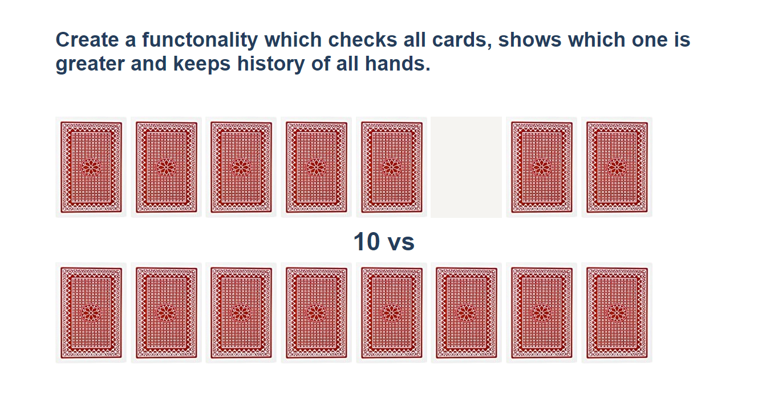
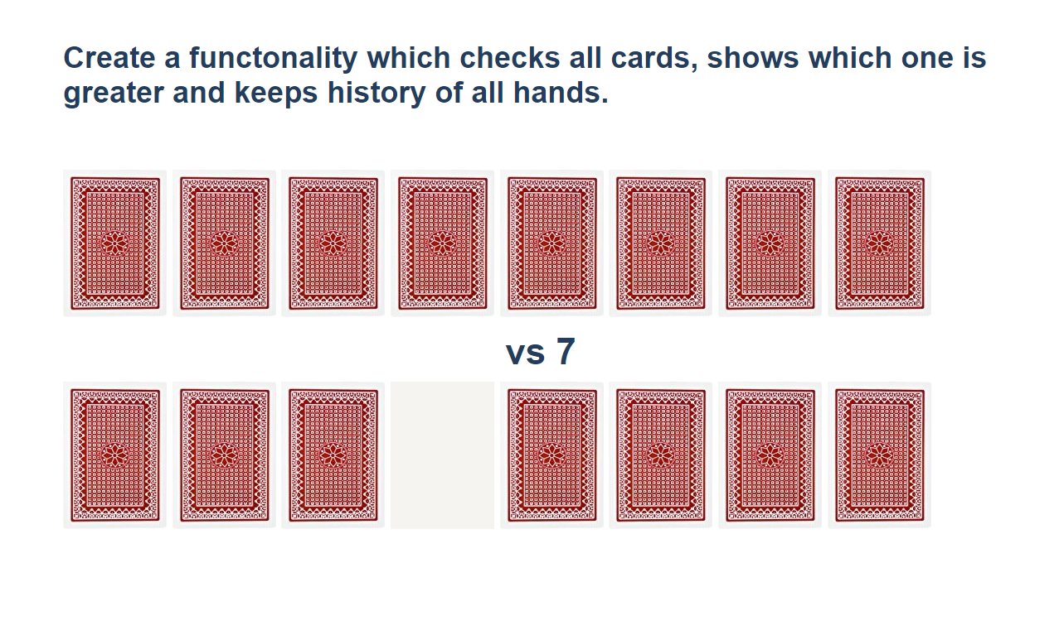
When cards from both sides are selected, check which one is greater. The greater card should have border "2px solid green" and the lower card - "2px solid red".
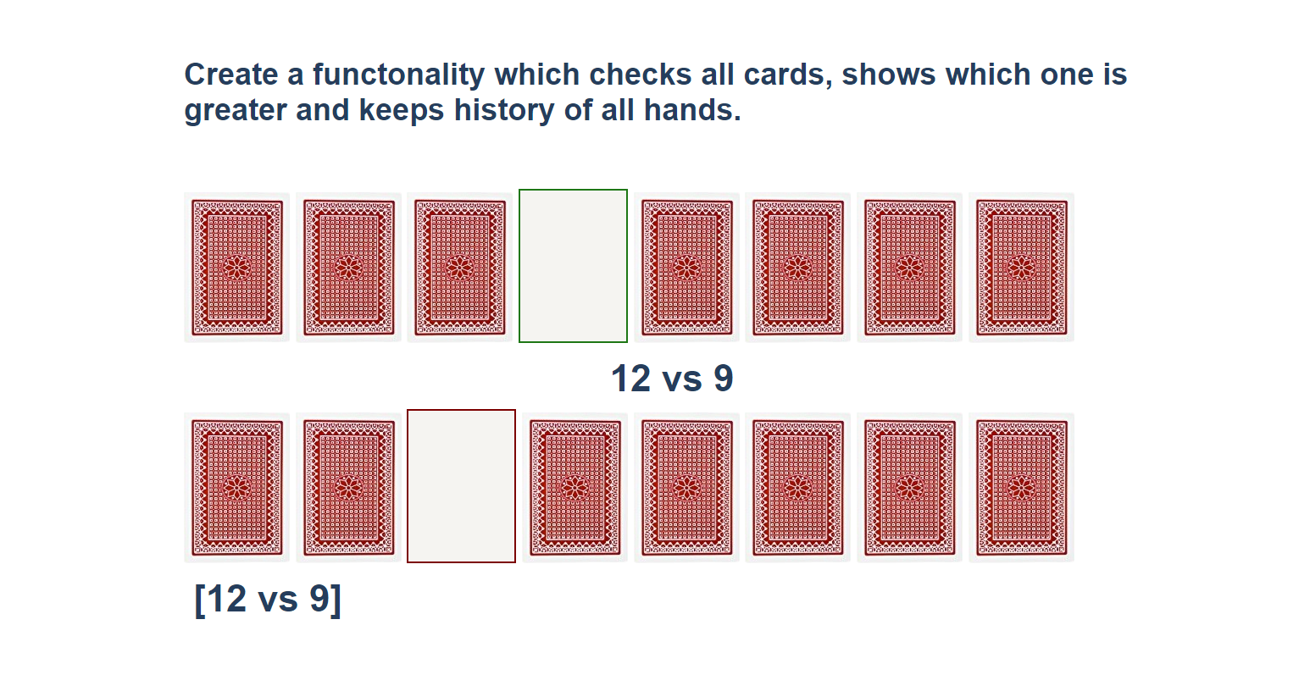
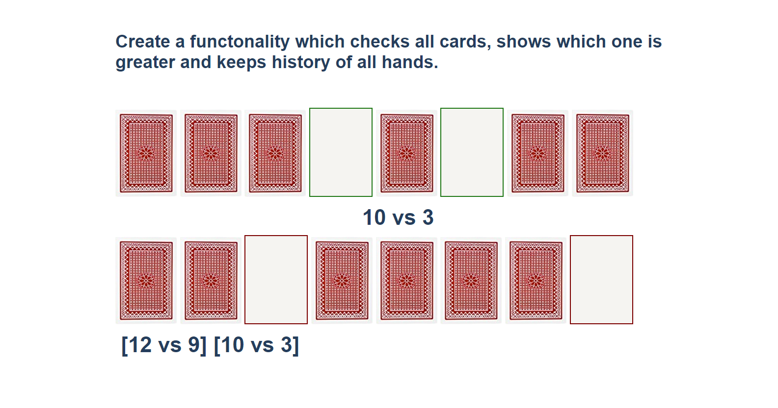
You should clear the span elements which hold the current card names when both are selected, and the winner is selected. After every hand, push the current card names in the history div in the following format:
[{top side card name} vs {bottom side card name} ]
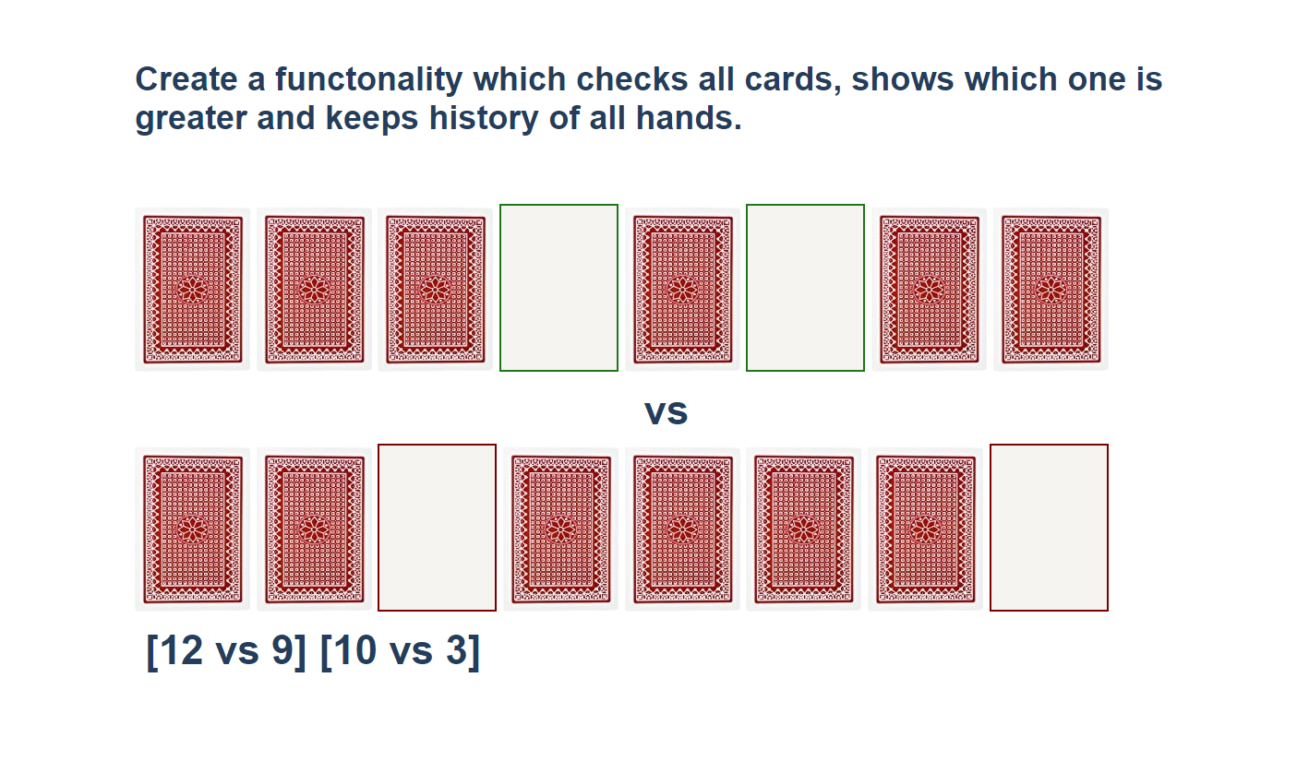

* Distance Converter
Your task is to convert from one distance unit to another by adding a click event listener to a button. When it is clicked, read the value from the input field and get the selected option from the input and output units drop downs. Then calculate and display the converted value in the disabled output field.

Example
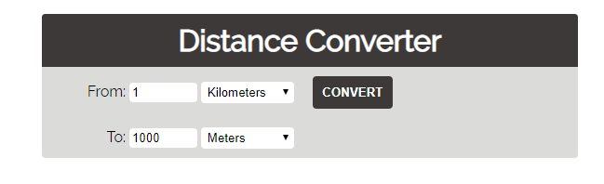

Hints
- Multiply the incoming distance by the following conversion rates to convert to meter
- Divide to convert from meters to the required output unit
- To see which option is selected, read the properties of its parent: value gives you the value of the selected option (as displayed in the HTML), selectedIndex gives you the 0-based index of the selected option. For example, if miles are selected, inputUnits.value is "mi", inputUnits.selectedIndex is 4. Option text is irrelevant
- Use the following table information to do that:
1 km | 1000 m
1 m | 1 m
1 cm | 0.01 m
1 mm | 0.001 m
1 mi | 1609.34 m
1 yrd | 0.9144 m
1 ft | 0.3048 m
1 in | 0.0254 m

* Sudomu
Write a function that implements SUDOMU (Sudoku inside the DOM).
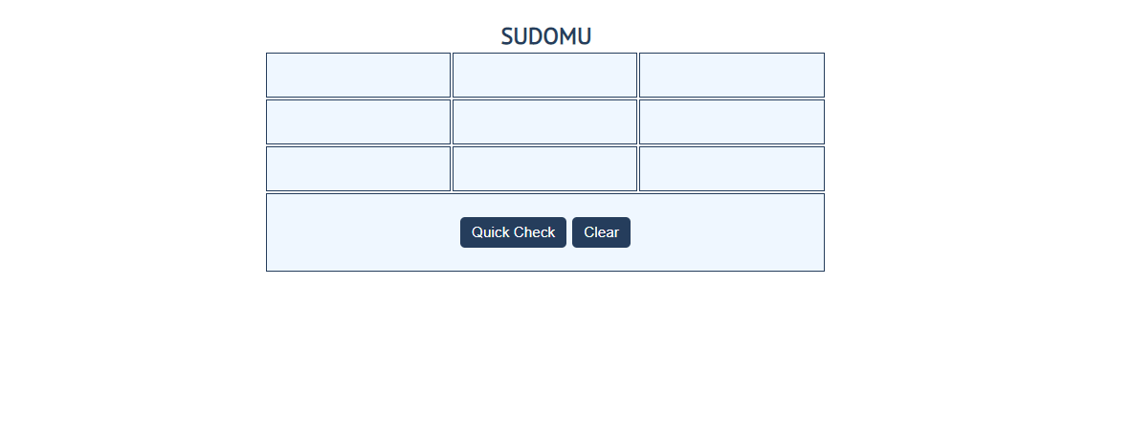
The rules are simple and they are the same as the typical sudoku game (for more information,
click here)
If the table is filled with the right numbers, and the "Quick Check" button is clicked, the
expected result should be:
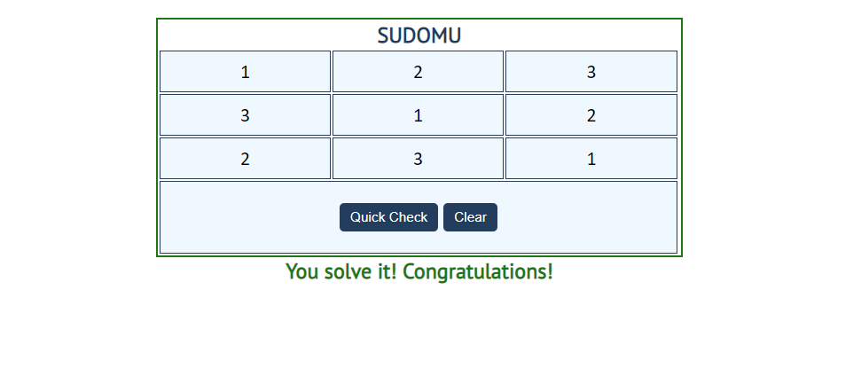
The table borer should be changed to: "2px solid green". The text content of the paragraph
inside the div with an id "check" must be "You solve it! Congratulations!"
The text color of that div must be green.
Otherwise, when the filled table does not solve the sudomu, the result should be:
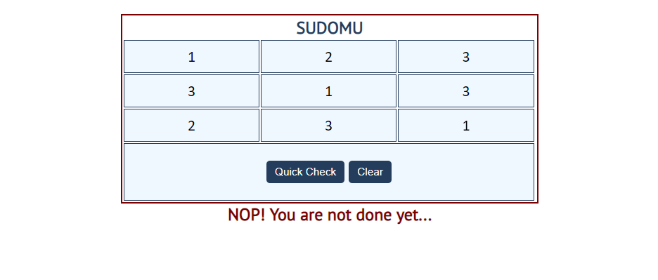
The table border should be changed to: "2px solid red".
The text content of the paragraph inside the div with an id "check" must be:
"NOP! You are not done yet…"
The text color of that div must be red!
The "Clear" button clears the whole SUDOMU (removes all numbers) and the paragraph
which contains the messages. It also removes the table border.

